Lab Exercise 17 - Creating Secrets in Kubernetes

Name: Anshi Agrawal
SAP ID: 500124498
Batch: 1 DevOps

Creating secrets in Kubernetes is an essential practice for managing sensitive information such as passwords, OAuth tokens, and SSH keys. Let's go through a lab exercise that demonstrates how to create different types of secrets in Kubernetes.

Step 1: Create a Generic Secret
Create a secret from literal values:
kubectl create secret generic my-secret --from-literal=username=admin --from-literal=password='P@ssw0rd'
Verify the secret:
kubectl get secrets my-secret -o yaml
The output will be base64 encoded. To decode, you can use:
echo -n “P@ssw0rd” | base64
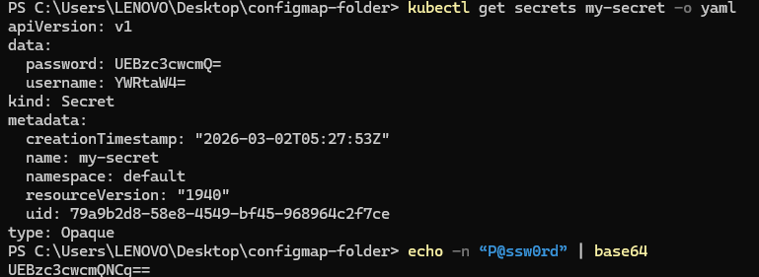

Step 2: Create a Secret from a File
Create a file with your sensitive data:
echo -n 'my-username' > ./username.txt
echo -n 'my-password' > ./password.txt
Create a secret from the file:

kubectl create secret generic my-file-secret --from-file=username=./username.txt --from-file=password=./password.txt
Verify the secret:
kubectl get secrets my-file-secret -o yaml

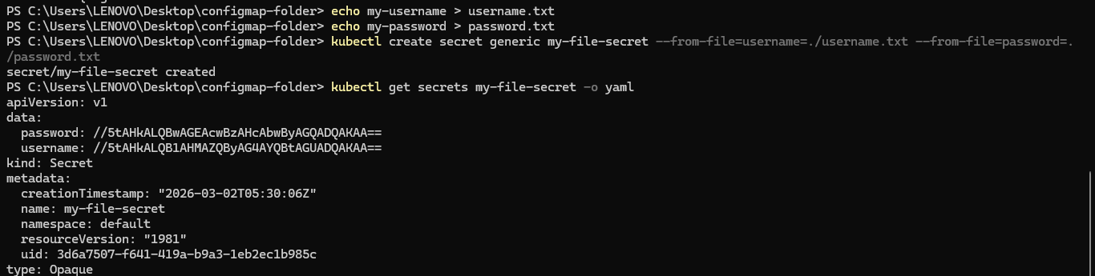

Step 3: Create a Docker Registry Secret
Create a Docker registry secret:
kubectl create secret docker-registry my-registry-secret --docker-username=<your-username>--docker-password=<your-password> --docker-email=<your-email> --docker-server=<your-docker-server>
Verify the secret:
kubectl get secrets my-registry-secret -o yaml
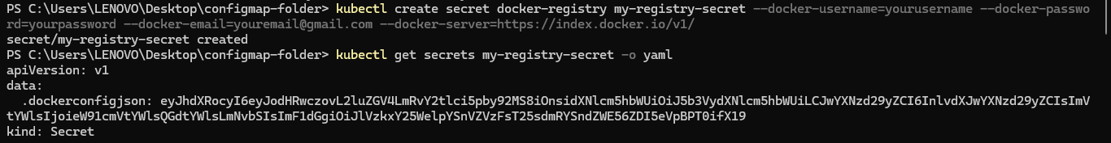

Step 4: Create a Secret Using a YAML Manifest
Create a YAML file for the secret:
Create a file named my-secret.yaml with the following content:
apiVersion: v1
kind: Secret
metadata:
name: my-manifest-secret
type: Opaque
data:
username: YWRtaW4= # base64 encoded value of 'admin'
password: UEBzc3cwcmQ= # base64 encoded value of 'P@ssw0rd'
Apply the YAML file:
kubectl apply -f my-manifest-secret.yaml
Verify the secret:

kubectl get secrets my-manifest-secret -o yaml
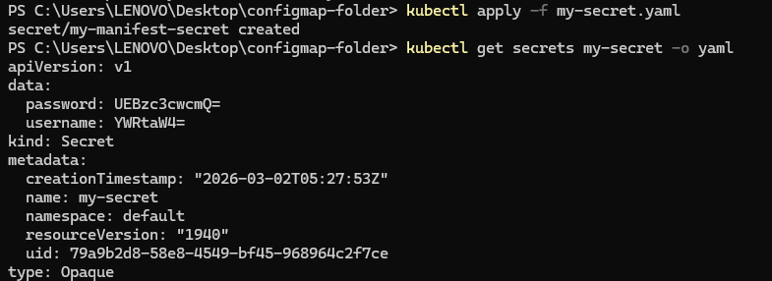

Step 5: Use Secrets in Pods
Create a pod that uses the secret:
Create a file named pod-with-secret.yaml with the following content:

apiVersion: v1
kind: Pod
metadata:
name: pod-with-secret
spec:
containers:
- name: mycontainer
image: nginx
env:
- name: USERNAME
valueFrom:
secretKeyRef:
name: my-secret
key: username
- name: PASSWORD
valueFrom:
secretKeyRef:
name: my-secret
key: password

Apply the YAML file:

kubectl apply -f pod-with-secret.yaml
Verify the pod is running and the secret is being used:
kubectl exec pod-with-secret -- printenv | grep -E 'USERNAME|PASSWORD'

Step 6: Clean Up
Delete the secrets:
kubectl delete secret my-secret
kubectl delete secret my-file-secret
kubectl delete secret my-registry-secret
kubectl delete secret my-manifest-secret

Delete the pod:
kubectl delete pod pod-with-secret
